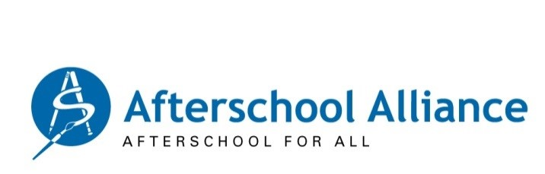
News Release
May 19, 2026
Contact: Magen Eissenstat, 202/609-9889

The Summer Struggle Is Daunting for Many Nebraska Families

New Study Finds 1 in 2 Nebraska Children Whose Parents Want Summer Learning Programs for Them Are Missing Out, Most Often Because of Cost

Washington, D.C. – Many more Nebraska parents want their children in a structured summer program than are able to enroll them, according to a household survey released today. The Summer Struggle for Nebraska Families finds that the parents of 134,442 Nebraska children want summer programs for them, but just 62,425 Nebraska children are enrolled. The barriers pushing programs out of reach for Nebraska families are cost, cited by 30% of survey respondents; program location or transportation challenges, cited by 18%; and programs being unavailable, cited by 12%.

An overwhelming majority of Nebraska parents who have been able to enroll their children in a summer program give them high marks, with 94% reporting satisfaction with the program their child attends. And a large majority of parents in the state (88%) support public funding for summer programs, including 90% of Democrats, 92% of Independents, and 88% of Republicans.

A structured summer program is defined in The Summer Struggle as an enrichment or sports program, summer camp or school, or a job or internship. It is part of the America After 3PM series of household surveys, conducted by Edge Research for the Afterschool Alliance. The new survey includes 30,515 U.S. parents of school-age children who live in their households, including 350 in Nebraska. Parents here say the factors they look for most in summer programs are a safe environment, opportunities to build confidence, and time for fun and educational activities and less screen time.

“In Nebraska and across the country, summer programs give children a safe place to go, provide alternatives to screen time, keep them physically active, reduce isolation, support learning, and give working parents peace of mind that their children are safe and constructively engaged while they are at work,” said Afterschool Alliance Executive Director Jodi Grant. “But finding summer programs they can afford is a real struggle for many Nebraska families. Every child deserves access to a quality summer program but sadly, we are far from reaching that goal. We need greater support from federal, state, and local governments, philanthropy, and businesses to change that.”

“The Summer Struggle for Nebraska Families is a sobering reminder that too many working families scramble to find summer programs for their children,” said Alison O'Toole, Network Lead of Beyond School Bells. “It shouldn’t be this difficult for families to access summer programs that will help their children engage, be active, avoid excessive screen time, and learn over the summer. We will work with local and state lawmakers and all our community partners to tackle this problem. Every Nebraska family deserves summer options they can afford.”

Nationally, the new study finds that the parents of 24.6 million U.S. children want a structured summer experience for their child but just 12 million of those children (49%) are enrolled.

Findings from all 50 states are here.

In most respects, Nebraska results mirror national findings, which include:

Affordability is the most common barrier faced by families unable to enroll their child.
- 38% of these families cite cost as a factor contributing to their inability to enroll their child in a summer program.
- 18% cite program’s location, or transportation as a reason.
- 13% report having difficulty finding a program, say summer programs are not available in their community, or the program’s hours do not meet their needs.
- 10% say programs had no open slots.

Parents with a child enrolled give summer programs high marks.
- 96% of these parents report being satisfied with the summer program their child attends, with 63% reporting extreme satisfaction.
- Half of parents with a child in a summer program (50%) say they are extremely confident their child will be well prepared for the coming school year, compared to 43% of parents whose child is not in a summer program.

Parents’ support for public funding for summer programs is strong and growing.
- Nine in ten parents (89%) favor public funding summer learning opportunities, up from 83% in 2009, 85% in 2014, and 88% in 2020.
- In the current study, 94% of Democrats, 89% of Independents, and 87% of Republican parents support public funding.
- 93% of parents in urban communities, 89% of those in suburban communities, and 87% of parents in rural communities support public funding.

Across demographic lines, parents want summer opportunities for all children.
- 87% of parents agree that all young people deserve access to quality afterschool and summer programs.
- 92% of parents who Democrats and 85% of those who are Independents or Republicans agree.
- 88% of parents in suburban and urban communities, and 85% of those in rural communities agree. Support is overwhelming in every region of the country.
- At least 86% of parents of every race/ethnicity agree.

The national and Nebraska America After 3PM 2025 summer findings and accompanying data are available at https://aa3pm.co/. This fifth edition of America After 3PM is based on a survey conducted in English and Spanish using a mixed-mode methodology to reach as many households as possible. Data were collected between January 31 and April 21, 2025. The margin of error for the child- and household-level data is +/- < 1 percent. Previous America After 3PM surveys were conducted in 2004, 2009, 2014, and 2020.

The America After 3PM summer findings are based on research funded by The Wallace Foundation.

# # # #

The Afterschool Alliance is a nonprofit public awareness and advocacy organization working to ensure that all children and youth have access to quality afterschool programs. More information is available at www.afterschoolalliance.org.

About The Wallace Foundation
Wallace is an independent, nonpartisan research foundation, with a mission to help all communities build a more vibrant and just future by fostering advances in the arts, education leadership, and youth development. We collaborate with grantees and research partners to design and test innovative approaches to address pressing problems in the fields we serve. The evidence-based insights we share—searchable online and free of charge—support policymakers and practitioners in their efforts to improve outcomes, enhance community vitality, and help all people reach their full potential.

