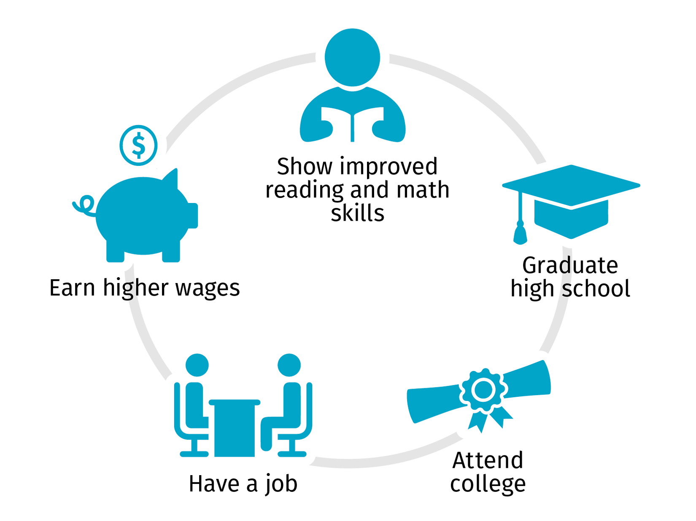
Quality childcare will have nurturing, responsive staff and environments that are developmentally appropriate. Children who receive quality early childcare and education are more likely to:
*A great resource to learn about quality childcare and what questions to ask a potential childcare provider is the Learning Begins At Birth resource:
https://learningbeginsatbirth.org/resources/ (pages 48 – 51)

https://www.education.ne.gov/stepuptoquality/qualitymatters/
Step Up To Quality (SU2Q) is Nebraska’s program for helping childcare providers who are committed to improving their quality of care. SU2Q is a path for providers to take and the specific “step” they are on should not be interpreted as their level of quality. For example, a provider in Step 1 is enrolled and beginning the process whereas a provider in Step 5 is receiving coaching. This does not mean that the provider in Step 1 is less quality than the provider in Step 5. To find the SU2Q provider list, go to: https://www.education.ne.gov/StepUptoQuality/parents-families/quality-child-care/ and click on the green button that says “Find a Step Up to Quality Provider” on the left hand side.

Below is a map of the communities that have Rooted in Relationships (RiR) Coordinators. The RiR Coordinators can direct parents and Central Navigators to the providers who are participating, or have participated, in the Rooted initiative. The RiR initiative partners with communities to implement evidence-based practices that enhance the social-emotional development of children, birth through age 8. By participating in Rooted, providers are actively working on improving their quality through professional development and coaching. Click on the following website to view community contact information: https://rootedinrelationships.org/communities/communities.html
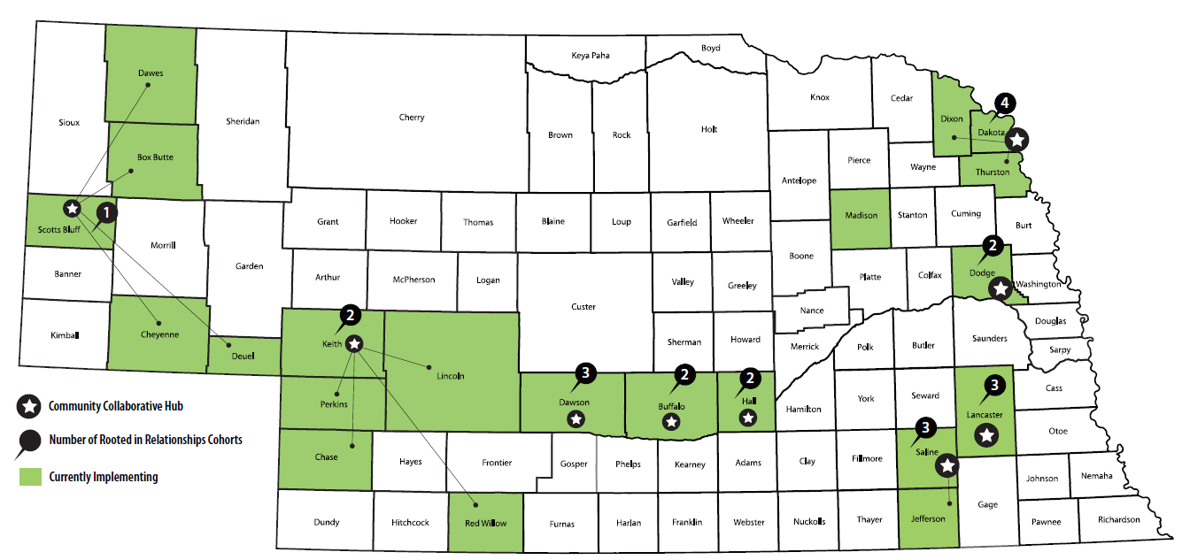
If you encounter any issues with the website or are unsure of who to contact within the communities, please call the Nebraska Children’s office at (402) 817-2017 and ask to talk to a Rooted in Relationships staff member.

To find a licensed childcare provider near you, including those that participate in SU2Q and accept childcare subsidy, visit the Nebraska Childcare Referral Network website: https://nechildcarereferral.org/.

