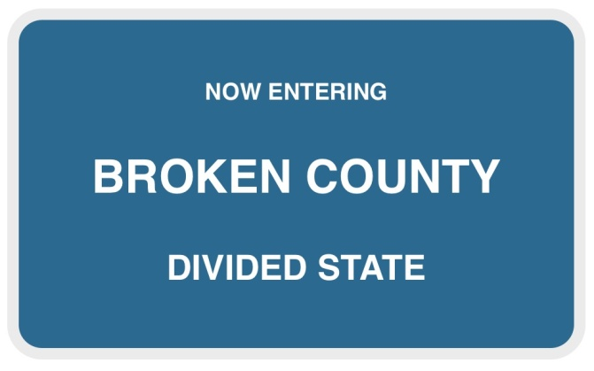
The Vision of Broken County Partnership for Child Well-Being
- Safe and Healthy Children and Families
- Children feel a sense of belonging and identity
- Active and invested families

- Sustainable Productive Holistic Programing
- Early intervention programs and strategies
- Total community teamwork and resources to provide holistic services

- Collaboration through Focused Leadership for Children and Families
- Strong leadership committed to the process and demonstrated through policies
- Open and sustainable communication
- Ongoing Assessment
Statement of Purpose and Belief for Broken County’s Partnership:
We believe that our children need to have:
- a safe school environment-- safe from threats outside the school as well as internal threats to safety
- a clear mind, unhampered by the numbing effects of tobacco, alcohol and other drugs, and violence
- access to mental health for the times when the ability to cope with life challenges becomes overwhelming
- a family or adequate substitute that provides for psychosocial development in early childhood as a foundation for a formal education
- a network of caring adults that link the school, families and community in a united effort to educate the whole child

It is our mission to provide for these needs in a collaborative effort from separate, equal, and independent agencies and individuals.
Our core beliefs and common goals unite us in a mutually respectful collaboration, bound by a shared vision and mission, and dedicated to sharing our talents and assets to this end because it is the right thing to do!

