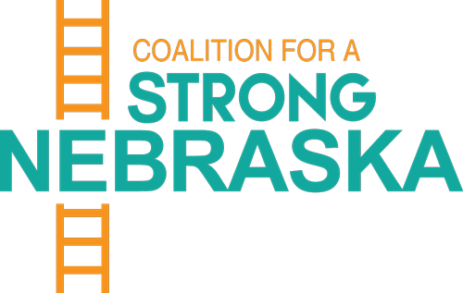
Coalition for a Strong Nebraska (CSN) Leadership Presenters
Heartland Workers Center: http://www.heartlandworkerscenter.org/
Our mission is to improve the quality of life of Latino/a immigrant workers by promoting leadership development, workers’ rights, and civic engagement through legal information sharing, training, and organizing.
- Micky Devitt, Legal and Policy Coordinator: micky@heartlandworkerscenter.org

- Call for: workers’ rights, immigrant, meatpacking, and essential worker safety, unemployment, wage and hour issues, civic engagement and tax policy
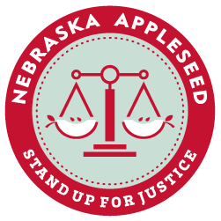
Nebraska Appleseed: https://neappleseed.org/

With expertise in addressing systemic problems affecting thousands of people, we incorporate legal advocacy, community activism, and policy expertise to make a positive, sustainable difference in our four main areas of concentration – health care access, poverty, child welfare, and immigration.

- Katie Pitts, Director of Public Policy: kpitts@neappleseed.org

- Call for: SNAP, Medicaid, worker safety, immigration, childcare benefits, racial equity, child welfare, housing and evictions
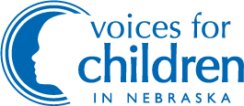
Voices for Children: https://voicesforchildren.com/

Voices for Children in Nebraska is the independent voice building pathways to opportunity for all children and families through research, policy and community engagement. We will engage the public and state leaders to build systems removing obstacles and promoting opportunities for ALL children to lead healthy, secure and fulfilling lives.
- Aubrey Mancuso, Executive Director: amancuso@voicesforchildren.com
- Call for: childcare subsidies, SNAP, Paid Family and Medical Leave, Paid Sick and Safe Leave, school meal programs, Coronavirus response, predatory lending, mental and behavioral health, Young Adult Bridge to Independence, Youth in Care Bill of Rights, juvenile justice, Student Discipline Act, Right to Counsel
Together Omaha: https://togetheromaha.org
Together's mission is to prevent and end homelessness in the Omaha and surrounding communities. This is done through strategic partnerships and collaborations with other nonprofit organizations, government, businesses and caring individuals. Together's core values of hope, dignity, compassion, excellence, and diversity is the guiding force in how the organization leads and serves those who need Together most.
- Erin Feichtinger, Director of Community Outreach and Advocacy: efeichtinger@togetheromaha.org

- Call for: affordable housing, safe housing, evictions, homelessness, access to food

