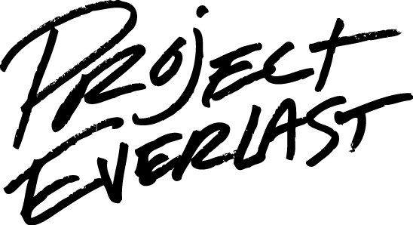**7 Quick & Easy Icebreakers**

*Taken from ywmovement.org*

Here are 7 quick and easy icebreakers to get your crowd at ease. You might just want to print these out and put them in your back pocket, just in case.

**Body Parts** – Every student gets a partner. One of the pair goes to the middle to form an inner circle, the other of the pair makes a larger circle around the inner circle. Outer circle begins to walk clockwise, inner circle walks counter-clockwise. Then the leader calls out two body parts like nose to elbow. The inner circle partner

finds the outer circle partner & they have to match up the body parts. Last duo to match up their parts is eliminated. Circle back up and keep going.

**I Never** – everyone sits in a circle of chairs except one person in the middle. Person in the middle states their name and something they have never done. Anyone who has done whatever was said, gets up in switches chairs. Example “I’m Erin and I’ve never been to a Disney theme park.” Everyone who has been to a Disney park gets up and switches spots, person in the middle tries to get a seat. Last person in the middle is “it” for the next round.

**Name Backwards Introduction** – Do a simple introduction and then ask the youth to say their name backwards, which always makes for a good nickname through a retreat. Funny part is that there is usually someone who’s name is the same backwards. ie. Anna

**Three Questions** – Each person in the group answers three questions. The questions are 1. What is your name? 2. What grade are you in & where do you go to school? And question #3 is wide open for creativity – if you could be any zoo animal (or car or color or food, etc.), what would you be and why?

**Two Truths and a Lie** – each participant writes down three statements in any order about themselves on a card, two are true and one is a lie. The trick is to make the lie believable. Gather all the cards, someone shuffles them. Read the cards aloud one at a time – group tries to guess who wrote the card & then which statement was false. Optional: you can keep score on who has the most correct guesses.

**What if….?** – Everyone gets two pieces of paper. On the first piece everyone writes a random question starting wi th “What if…” For example: “What if dogs could talk?” or “What if you could turn anything into chocolate?” On the second piece of paper, students write an answer to the questions, such as “We would have to hear about squirrels a lot more.” Or “Brussel sprouts would taste better than ever.” After everyone is done writing, put questions in one pile and answers in another. Shuffle the papers and then randomly pick one question and one answer. Read aloud and laugh.

C:\Users\crockwell\AppData\Local\Microsoft\Windows\Temporary Internet Files\Content.IE5\3S7I2VQN\MC900012913[1].wmf**Would You Rather** – Gather your group together and the leader calls out a “Would your rather…” statement. Participants can answer by moving from one side of the room or the other, sitting or standing, writing their answers, sharing their answers – whatever works best for your group. Examples of “Would your rather questions” are: Would your rather…go to the beach or the mountains? Be able to stop time or to fly? Be the most popular person or the smartest person? Go without your phone for a month or not see your best friend for a month?