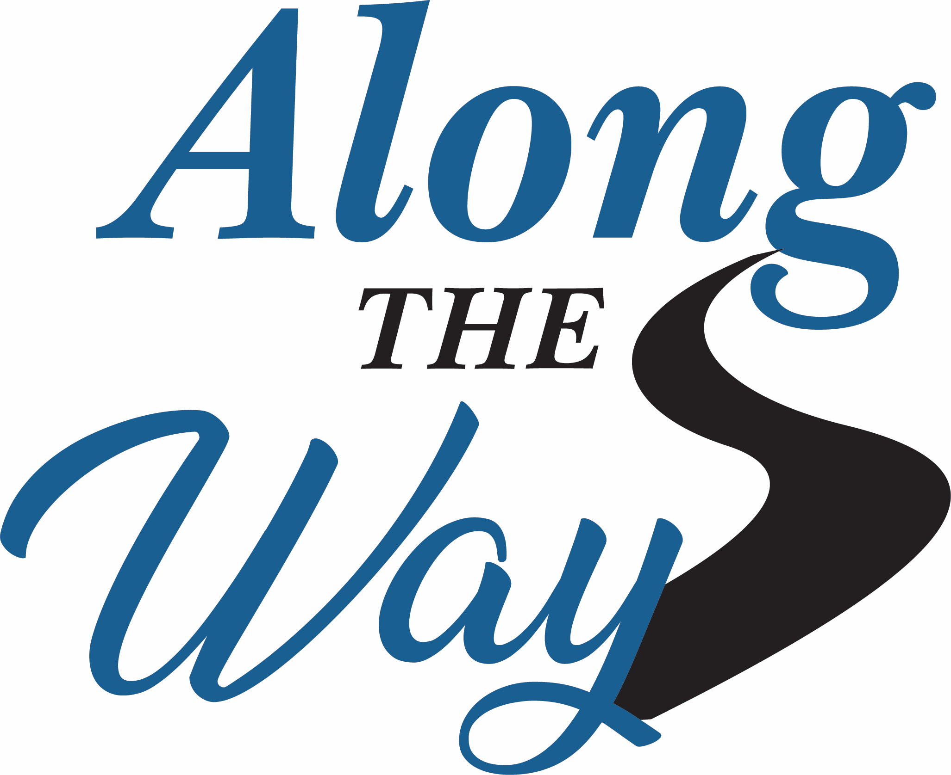

Along the Way is a series of resource guides for Nebraskans with intellectual and developmental disabilities (I/DD). Developed by Fritz & O’Hare Associates under a grant from the Nebraska Council on Developmental Disabilities (DD Council), the guides are designed to assist people with I/DD, their families, and professionals in navigating the complicated systems of services and supports.

Along the Way provides information and resources for people with I/DD of all ages, with a comprehensive resource guide and three separate guides to address the life stages of: Infants, Toddlers, and Children; Adolescents and Young Adults; and Adults. To view or download the guides, go to: http://dhhs.ne.gov/Pages/DD-Planning-Council-Resources.aspx

Update on 2021 Activities! The DD Council recognized that simply printing information and hoping people use it is not enough. The Council awarded additional grant funding to Fritz & O’Hare to build upon this important work in 2020. The plan was to travel across the state to meet in-person with professionals to share information on ways to incorporate the guides in their work. Unfortunately, the events of 2020 changed this plan.

However, the need to continue this work has not changed. It’s important that we adapt the plan to fit within the challenges of the pandemic. With groups no longer or infrequently meeting in person, we are currently offering virtual presentations to deliver the message and share our materials. Our presentation is brief (15-20 minutes) and interactive, so we believe it could fit well within a group’s meeting or conference agenda.

Examples of groups who may benefit include schools, Educational Service Units, advocacy organizations, state agencies, developmental disability providers, early childhood professionals, or any group interested in learning about resources for people with I/DD.

Bonus! A limited number of copies may be available (while quantities last) for use in your areas. If your organization is interested in scheduling with us or you want to know more, contact information is below. Please contact us soon to get on our calendar. We hope you will take advantage of this important resource for Nebraskans!

