Program Development
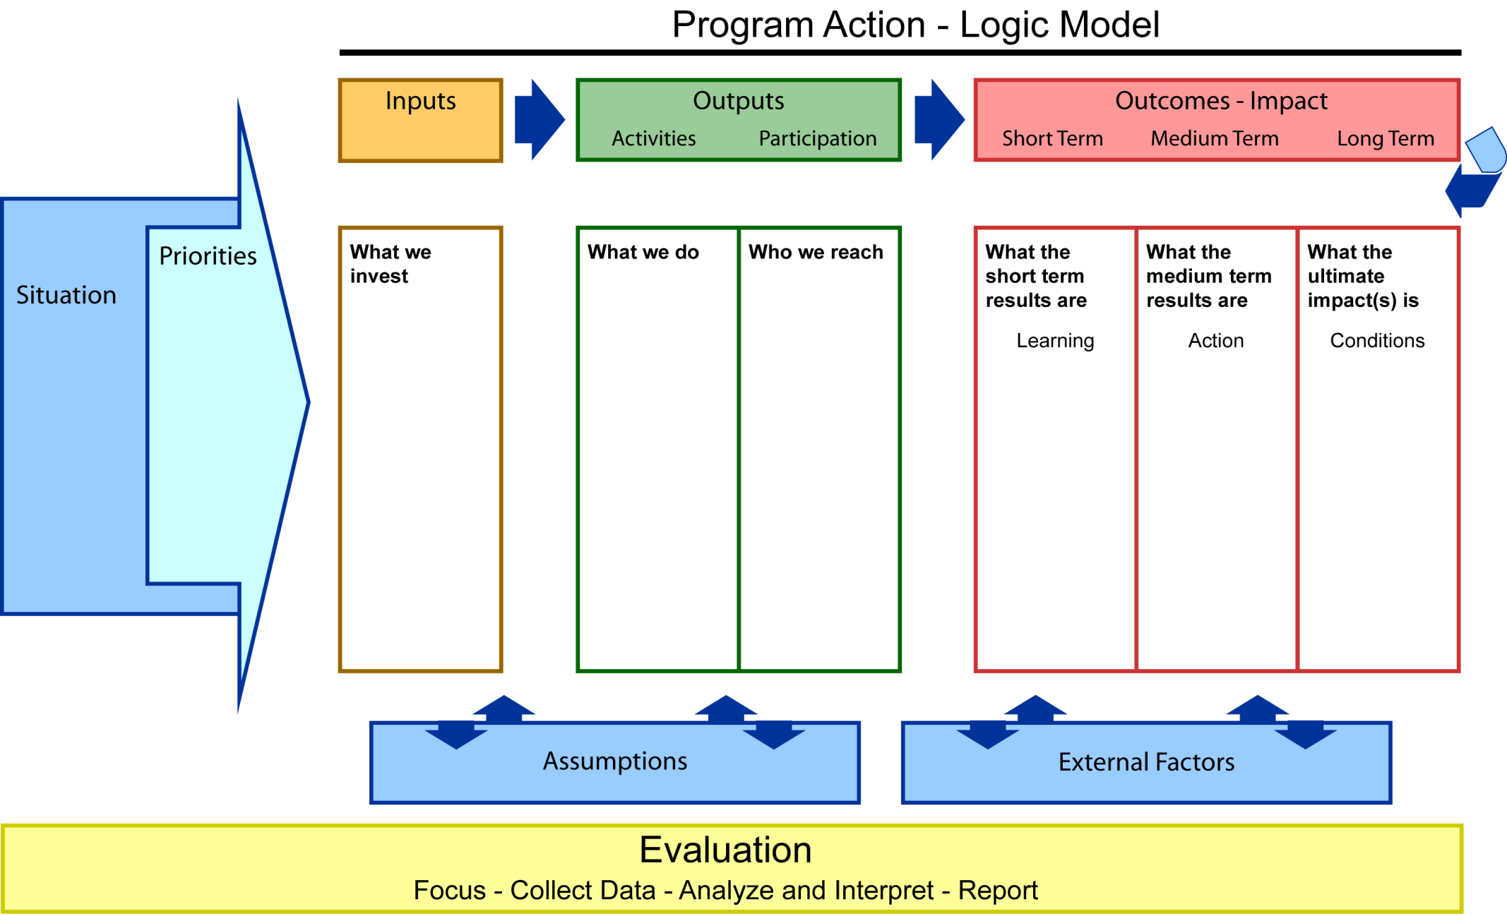
Planning – Implementation – Evaluation D R A F T

Community mobilization of resources.

Policy change occurs that facilitate safe and nurturing communities

Family Protective Factors are in place.

Duplication of services is reduced.

Parents use nurturing parenting practices.
Committed diverse community members engage in open dialogue to address community concerns.

A system's collaborative infrastructure addresses shared outcomes for child well-being.

An integrated Child Well-Being plan is informed by community assessment and EBP.
.
Implement EBP strategies to:
1) Change community’s normative standards.
2) Strengthen a Prevention System
(Diverse array of quality accessible services and resources)
3) Develop and sustain a collaborative partnership to accomplish goals
4) Strengthen positive parent child interaction
Science supports designs that integrate the best practices of both program and community building to achieve results that are broad, deep, and self-sustaining.

Socio-Ecological Approach
Grant Dollars

Training

Technical
Assistance

Collaboration

State and National
Resources

Peer Networks

Capacity Building:
Organizational Program
Leadership
Community Engagement

Change Makers

Service Providers

Community Stakeholders

Parents and Children
Improved child well-being (Children who are healthy, safe, ready and successful in school, and have secure and nurturing relationships).
Outcomes – Impact
Short Term Medium Term Long Term
*LE-Local Evaluator Responsibilities
Measure

Indicators/Measures:

- Infant Mortality
- Low birth weight
- Obesity
- Adolescent substance abuse
- Teen pregnancy
- High School Drop Out
- Juvenile Arrest rate
- Child Abuse and Neglect
Outcome

Improved child well-being (Children who are healthy, safe, ready and successful in school, and have secure and nurturing relationships)

Outcome

Committed diverse community members engage in open dialogue to effectively address concerns of the community.

Each community has a systems collaborative infrastructure to address shared outcomes for child well-being.

An integrated implementation plan is informed by community assessment and EBP to enhance Child Well-Being.

Measure
Descriptive data:
- ODSS (LE* monitors)
- Document the degree of agreement on vision (systems collaborative agreement signed by organizations/stakeholders)
- Document the different paths to outcomes/(ODSS)
Qualitative data:
- Review of documents
-Child wellbeing assessments (NCFF Evaluators)
- Interviews of key informants through annual focus group (LE*)
-Describe the diversity of members having a voice
-Increased knowledge and awareness of existing coalitions, programs, planning initiatives, practices and policies related to child well being efforts

Community Survey:
Pre survey to determine a broad measure of community well being

Document submission of the integrated assessment findings and work plan to enhance Child Well-Being.

Outcome
Community mobilization of human and financial resources strengthens the community prevention system through improved quality, access to and integration of services. (ODSS)

Organizational or environmental policy change occurs to facilitate safe and nurturing communities.
(ODSS)

Duplication of services and gaps in service are reduced (Service Array and LE interviews)
(ODSS)

Parents use effective nurturing parenting practices to support their children’s well-being. (Relationship measures, child measures)

Family Protective Factors are adequately in place for child well-being. (At a program level)

Measure

ODSS (LE* monitors))

Qualitative Interview of Key Informants (LE*)

INDIVIDUAL LEVEL

FRIENDS:
Protective Factors survey. (LE)

Other evaluation may be individualized by community.

EXAMPLES:
Measures of Relationship

40 Developmental Assessments- evaluation of the system. (LE)

EBP and EIP Checklist

Measures of relationship between parent and child, child and parent. (LE) Examples: Keys for Interactive Parenting or Devereux Early Childhood Assessment (LE)

