TWITTER

Post on December 3
Yes, you can have the #flu and #Covid19 at the same time. So, get a #FluShot today to build your immunity! #DoRightRightNow

Additional resources >> https://dorightrightnow.org/

Use graphic below (it’s attached to the email):

Post on December 4
Fighting #Covid19 is a team effort and we need all of #HuskerNation to pitch in. Practice #SocialDistancing, choose the right mask & #MaskUp to protect yourself! #GBR #DoRightRightNow

Additional resources >> https://dorightrightnow.org/

Use graphic below (it’s attached to the email):

Continued…

Post on December 6
Please #DoRightRightNow to stop the spread of #Covid19. Do it for yourself, your family, your friends, and for our healthcare heroes! For resources and additional information visit https://dorightrightnow.org/videos/

Use graphic below (it’s attached to the email):
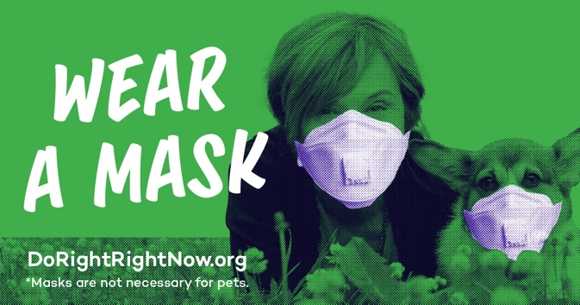

FACEBOOK & INSTAGRAM

Post on December 3
🤔 Is it possible to have the #flu and #COVID19 at the same time?

👩🏽‍⚕️️ Yes, because co-infection sometimes occurs with viruses. So, get a flu shot ASAP to build your immunity! #DoRightRightNow

For additional resources visit https://dorightrightnow.org/

Use graphic below (it’s attached to the email):
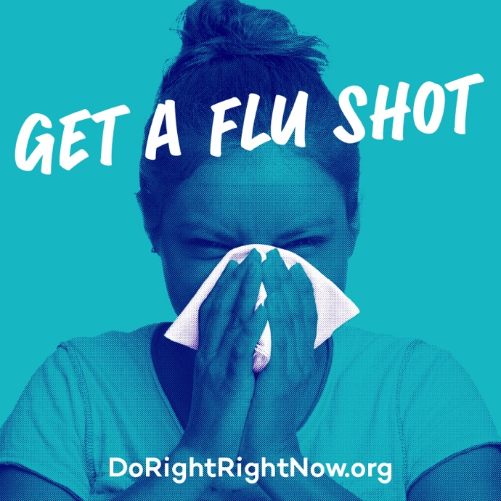

Continued...
Post on December 4
Fighting #Covid19 is a team effort and we need all of Husker Nation to pitch in. Practice social distancing, choose the right mask to protect yourself and others, and wash your hands! #GBR #DoRightRightNow

For additional resources visit https://dorightrightnow.org/

Use graphic below (it’s attached to the email):
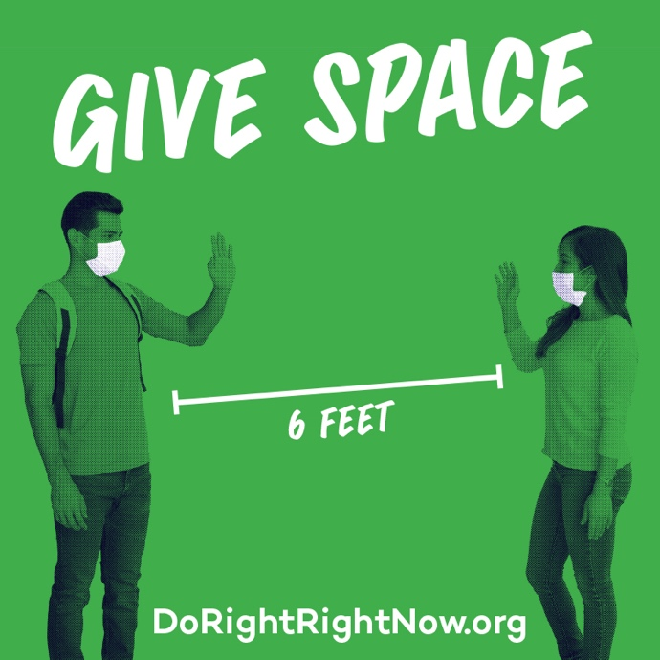

Post on December 6
Please #DoRightRightNow to stop the spread of #Covid19. Do it for yourself, your family, your friends, and for our healthcare heroes! For resources and additional information visit https://dorightrightnow.org/videos/

Use graphic below (it’s attached to the email):
