Community Support Specialist (CSS) /Family Focus Case Management (FFCM) 2020

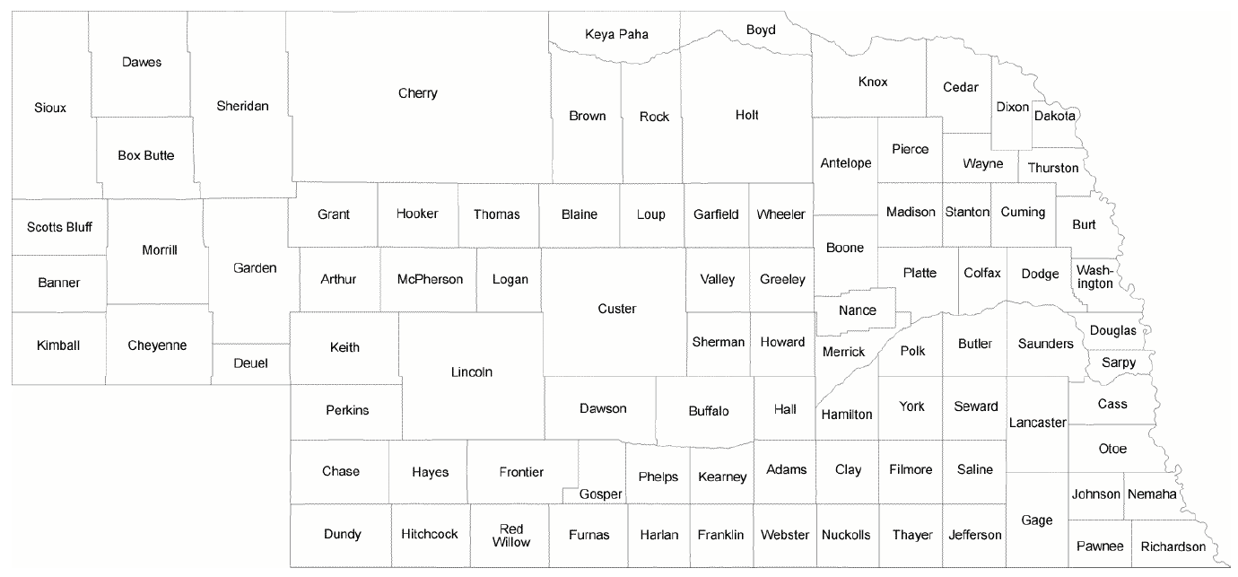
Community Support Specialists:
Shelly Witt– Western/Central – 402-984-9905 – shelly.witt@nebraska.gov
Stacy Schenk – Northern/Central – 402-375-7055 – stacy.schenk@nebraska.gov
Darla Berger – Sarpy/Douglas County/Southeast – 402-595-3314 – darla.berger@nebraska.gov
Darniece Amos – Douglas County/Eastern – 402-595-3369 – darniece.amos@nebraska.gov

Family Focus Case Managers:
Margot Dainowski – South Central – 308-535-8200
Sarah Nowak – Hall/Howard Counties – 308-385-6100

